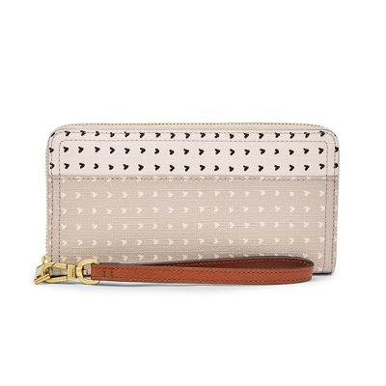

Logan RFID Zip Around Clutch

PRODUCT DETAILS

**Silhouette: Zip Around Clutch**

**Tech Compatibility: iPhone® 6 Plus, iPhone® 7 Plus, iPhone® 8 Plus**

**Exterior Material: 100% PVC/Polyurethane Trim**

**Interior Details: 1 Zipper Pocket, 2 Bill Compartments, 3 Gusseted Pockets, 12 Credit Card Slots**

**Measurements: 7.75"L x 0.75"W x 4"H**

**Warranty: 1 Year Limited**